A.

1)      Get the names of parts that cost less than 20.00.

select * from parts where price > 20.00 allow filtering;

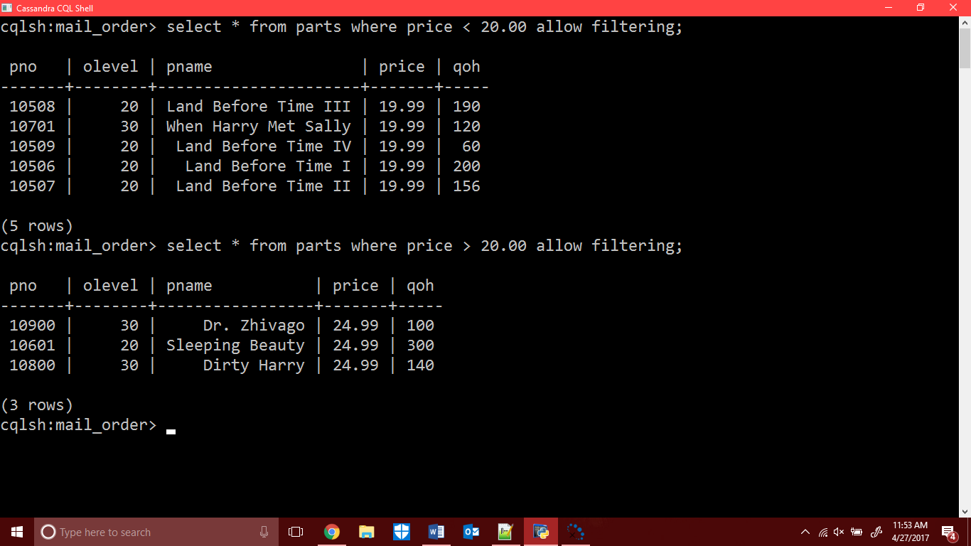

2)      Look-up order information given an order number.

select ono from orders;

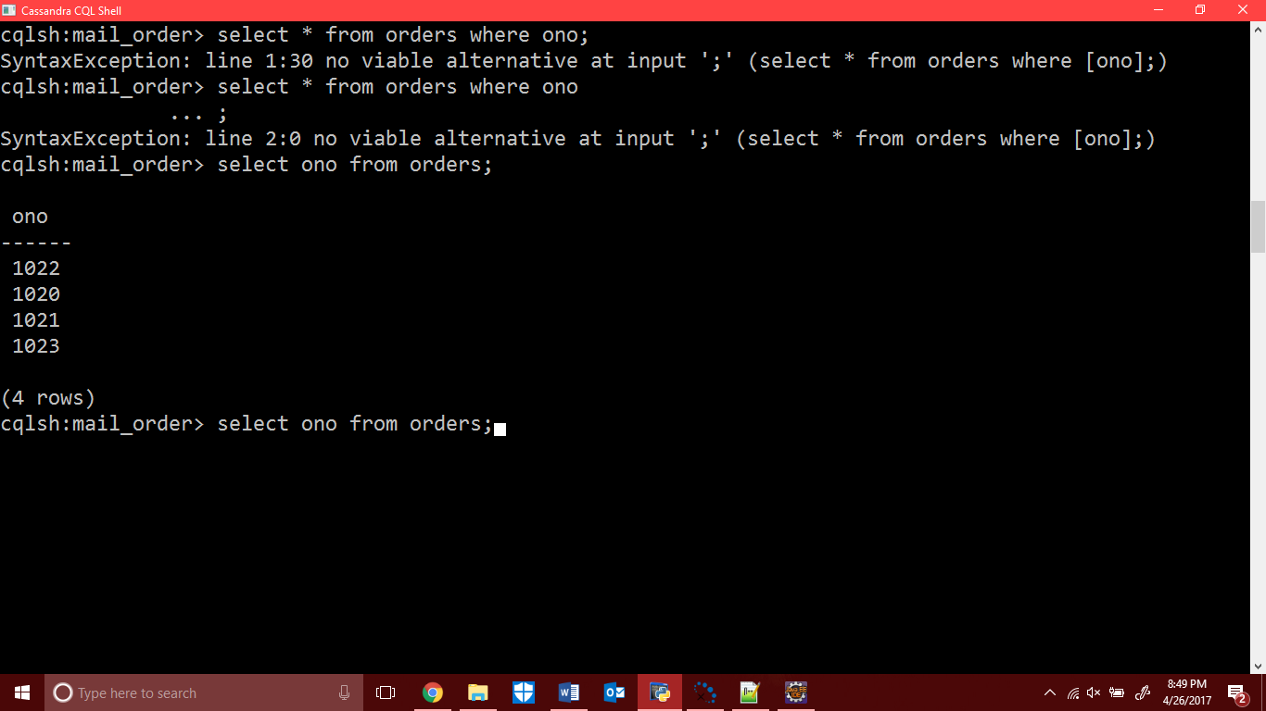

3)      Look-up order information given a customer number.

Select cno from orders;

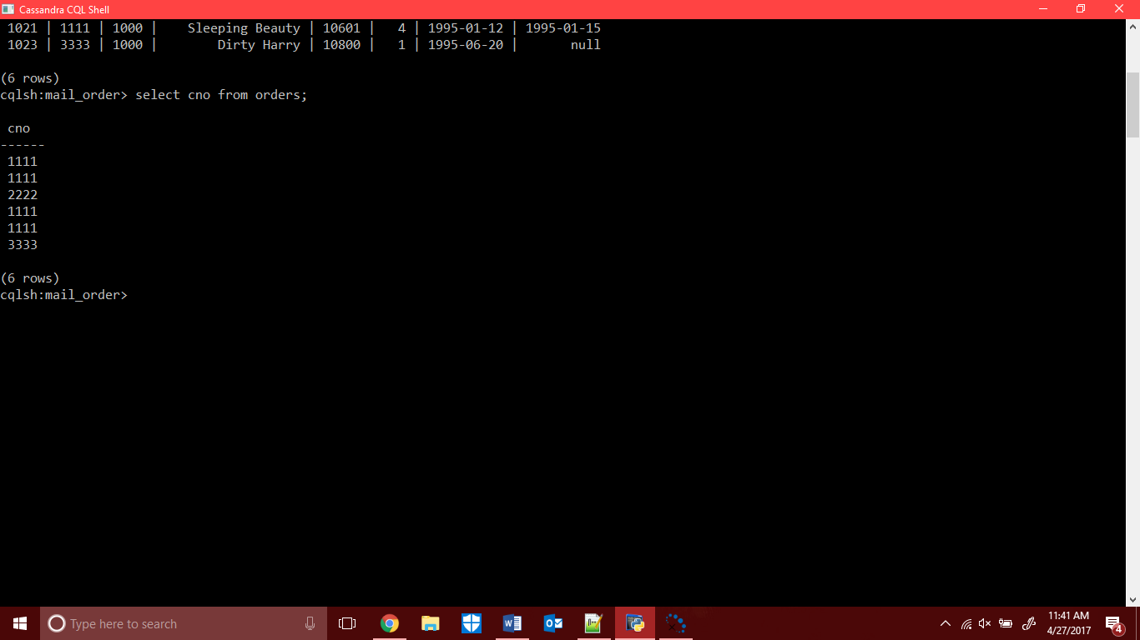

Select ono, cno, pname, qty, received, shipped, from orders;

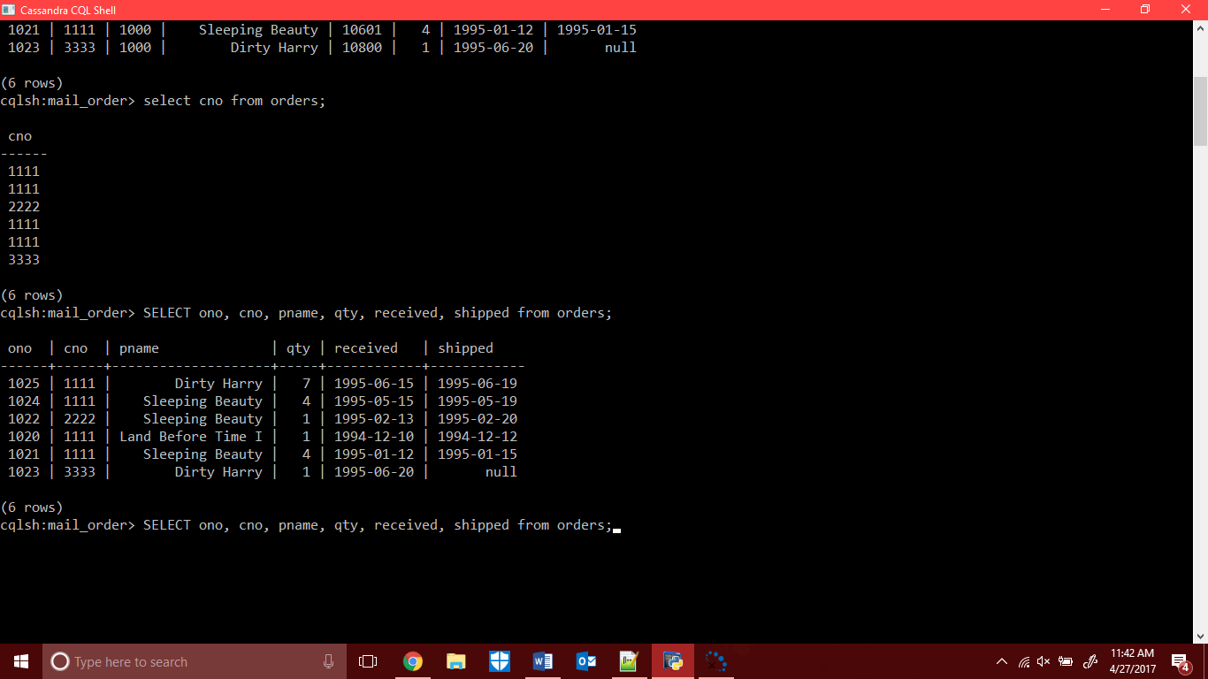

B.

CREATE TABLE **parts** (**pno** int PRIMARY KEY, **pname** varchar,

**qoh** int,

**price** double,

**olevel** int);

INSERT INTO **parts** (**pno**, **olevel**, **pname**, **price**, **qoh**)

VALUES (10506, 20,'Land Before Time I', 19.99, 200);

INSERT INTO **parts** (**pno**, **olevel**, **pname**, **price**, **qoh**)

VALUES (10507, 20, 'Land Before Time II',19.99,156);

INSERT INTO **parts** (**pno**, **olevel**, **pname**, **price**, **qoh**)

VALUES (10508, 20,'Land Before Time III',19.99 ,190);

INSERT INTO **parts** (**pno**, **olevel**, **pname**, **price**, **qoh**)

VALUES (10601,20,'Sleeping Beauty',24.99 ,300);

INSERT INTO **parts** (**pno**, **olevel**, **pname**, **price**, **qoh**)

VALUES (10509, 20,'Land Before Time IV',19.99,60);

INSERT INTO **parts** (**pno**, **olevel**, **pname**, **price**, **qoh**)

VALUES (10701,30,'When Harry Met Sally',19.99,120);

INSERT INTO **parts** (**pno**, **olevel**, **pname**, **price**, **qoh**)

VALUES (10800,30,'Dirty Harry',24.99,140);

INSERT INTO **parts** (**pno**, **olevel**, **pname**, **price**, **qoh**)

VALUES (10900,30,'Dr. Zhivago',24.99,100);

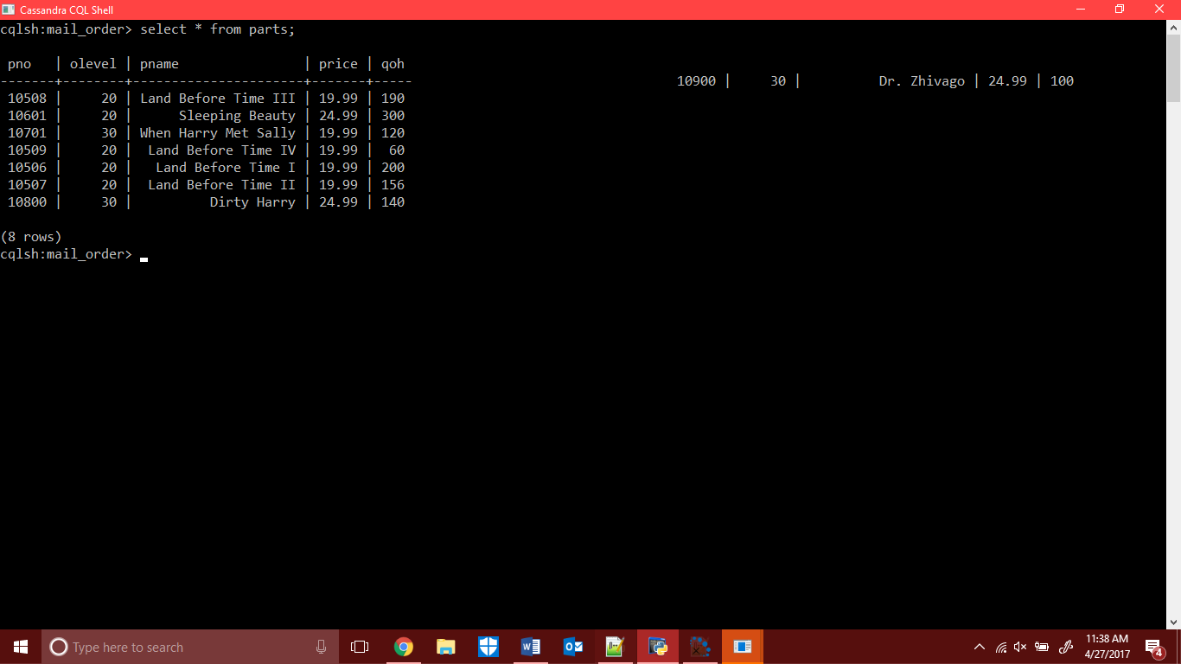

CREATE TABLE **orders** (**ono** int PRIMARY KEY,

**cno** int,

**eno** int,

**received** date,

**shipped** date);

INSERT INTO **orders**(**ono**, **cno**, **eno**, **pname**, **pno**, **qty**, **received**, **shipped**)

VALUES (1020, 1111, 1000, 'Land Before Time I', 10506, 1, '1994-12-10', '1994-12-12');

INSERT INTO **orders**(**ono**, **cno**, **eno**, **pname**, **pno**, **qty**, **received**, **shipped**)

VALUES (1021,1111,1000,'Land Before Time II',10507,1,'1995-1-12', '1995-1-15');

INSERT INTO **orders**(**ono**, **cno**, **eno**, **pname**, **pno**, **qty**, **received**, **shipped**)

VALUES (1022,2222,1001,'Sleeping Beauty',10601,1,'1995-2-13','1995-2-20');

INSERT INTO **orders**(**ono**, **cno**, **eno**, **pname**, **pno**, **qty**, **received**, **shipped**)

VALUES (1023,3333,1000,'Dirty Harry',10800,1,'1995-6-20',null);

INSERT INTO **orders**(**ono**, **cno**, **eno**, **pname**, **pno**, **qty**, **received**, **shipped**)

VALUES (1021,1111,1000,'Sleeping Beauty',10601,4,'1995-1-12', '1995-1-15');

INSERT INTO **orders**(**ono**, **cno**, **eno**, **pname**, **pno**, **qty**, **received**, **shipped**)

VALUES (1024,1111,1000,'Sleeping Beauty',10601,4,'1995-5-15', '1995-5-19');

INSERT INTO **orders**(**ono**, **cno**, **eno**, **pname**, **pno**, **qty**, **received**, **shipped**)

VALUES (1025,1111,1000,'Dirty Harry',10800,7,'1995-6-15', '1995-6-19');

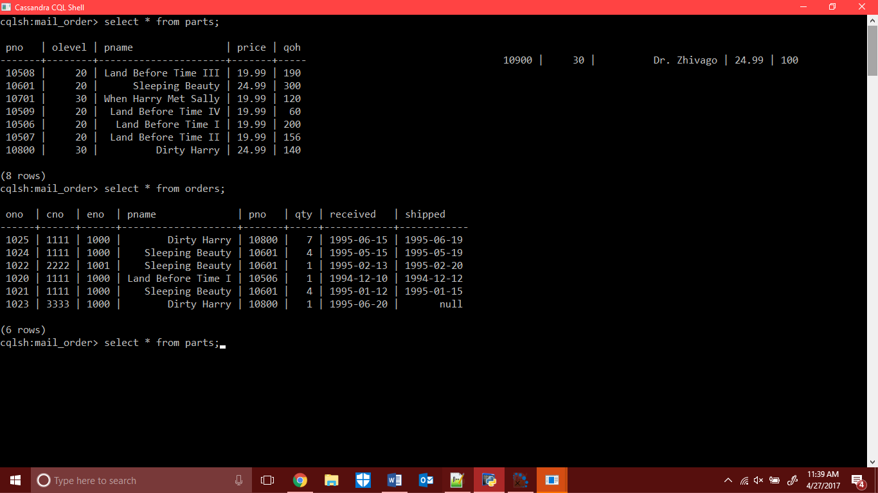

C.

Select pname from parts where price > 20.00 allow filtering;

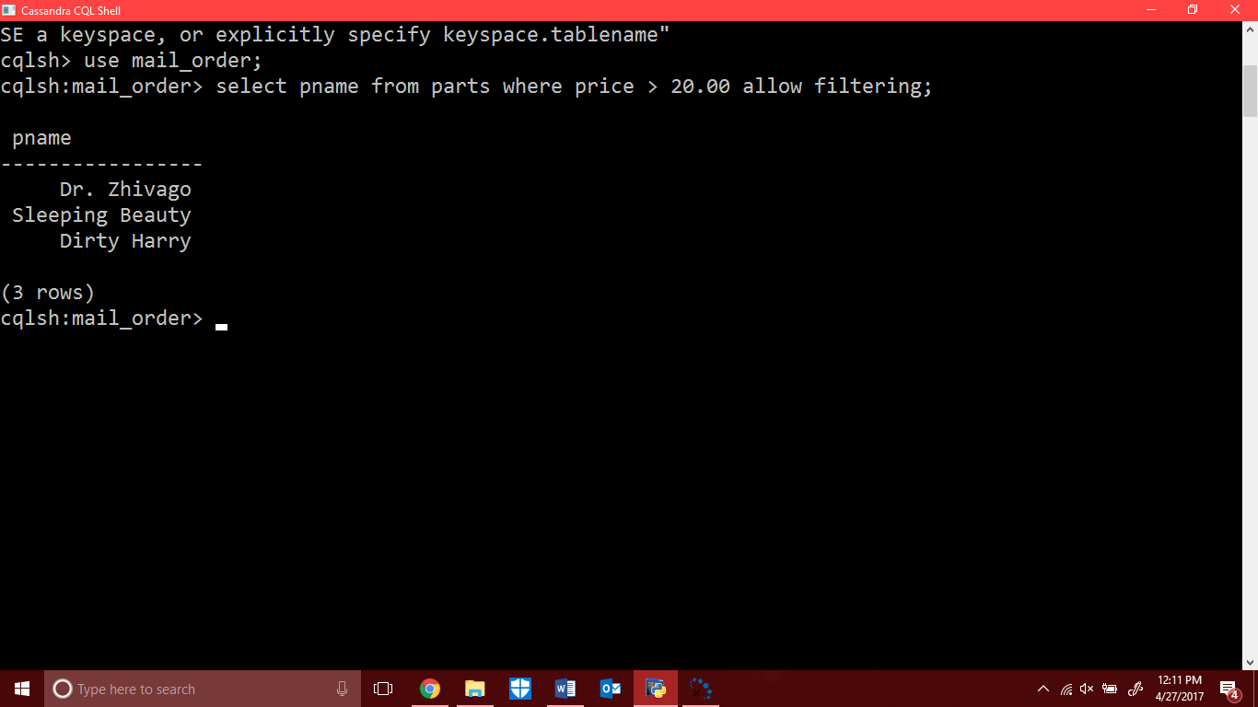

In Cassandra we cannot specified limited like we do in SQL.

For example,

In SQL we write “cno number(5);” for maximum we put 5 character in cno field also ,

But in Cassandra we don’t need to specified any character “cno int.”.

* In we use expand on; command then we run select * from parts; we got expand parts table.

Command is 1. expand on; 2. Select* from parts;

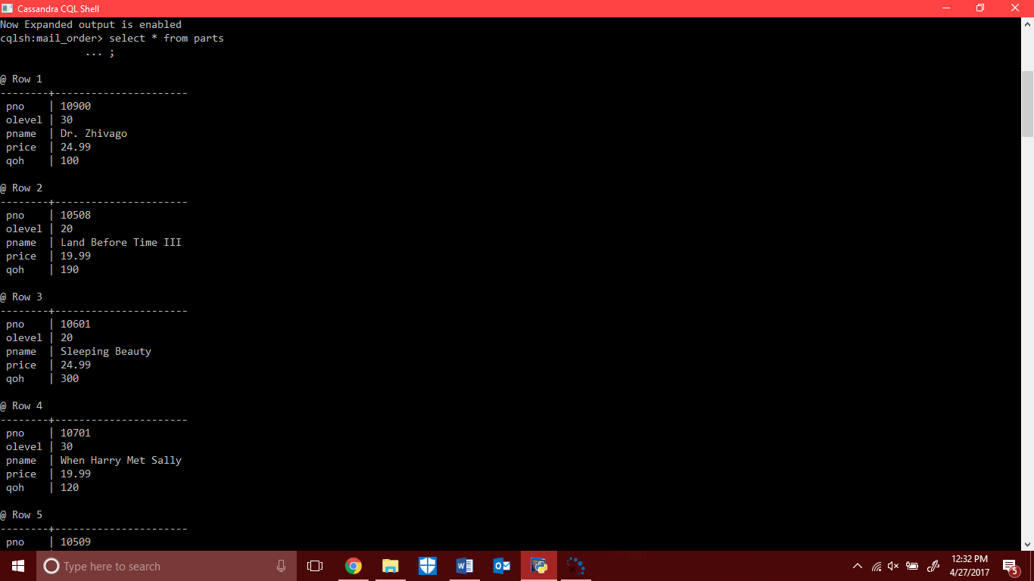

And we also disabled to expand command.

* Select pname, cno, ono from where qty < 1 allow filtering;
* Select pname, cno, ono from where qty > 1 allow filtering;

